Motor driver L298N

Testing

Testing is done to ensure proper functionality of the circuits. Indivisual circuits & modules should be tested saperately so that there will not be any problems in further design.

L298 Board after soldering( 2 channel)

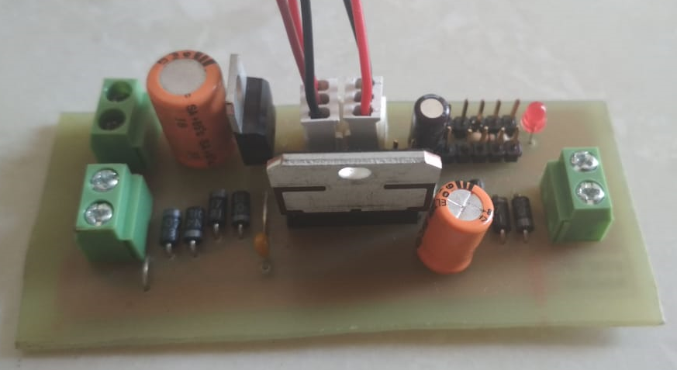

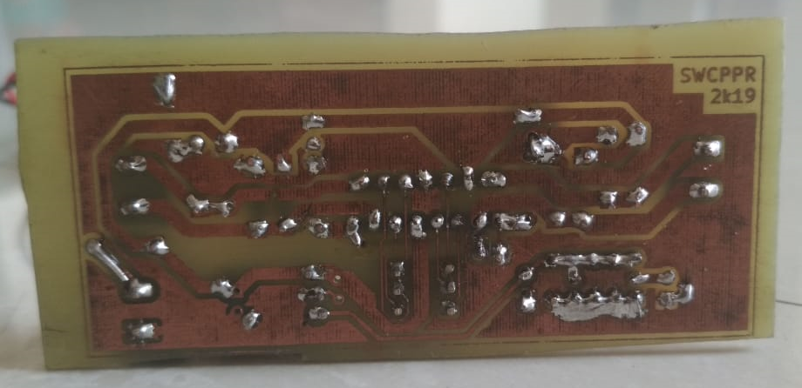

We tested the board in 3 steps

* Component test

We checked that ,all the components are in place & soldered properly or not.

* Continuity test
* By using DMM we checked the continuity of tracks to ensure the proper conduction of the circuit.
* Some points that are supposed to be isolated but get connected by mistake are also found out by continuity test.
* Functionality test
* In this step we check the actual operation of the circuit.
* This includes applying input and checking weather circuit is giving proper output or not.
* We gave conrol signals using 5v & GND headers on the board and checked the output voltage using DMM.
* Output voltage should be positive for clockwise and negative for counter-clockwise direction.
* We performed this test for both the channels & got proper output.

////////??????testing images